Product Name: Hydrogen Peroxide Sterilization Process Indicator Ink
For use in Monitoring: Hydrogen Peroxide |  |  |  | Appearance: Violet Liquid
 | 210101-10P |  | IPVP-01 |  | Origin of Manufacture: United States
 | 01-JAN-2021 |  | 01-MAY-2021

Characteristic | Specification | Result
pH (at 25˚C) | 9.0 - 10.5 | 9.5
Viscosity, Zahn Cup No. 2 | 15 – 30 seconds | 25 seconds
Color Transition  (≥6 minutes at 50ºC ± 2˚C in VH₂O₂) | Violet to Pink | Pass
Date of Product Performance Verification: | January 2021

Color Transition: Color transition will vary depending on exposure conditions, application of ink in terms of thickness and product build.

Storage and Shelf Life
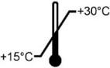 | Room Temperature (15º - 30ªC) |  | Keep away from sunlight
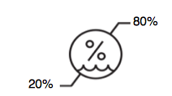 | 20% to 80% Relative Humidity |  | Protect from heat, radioactive sources, and sterilizing agents
 | Do not freeze. | Shelf Life | 4 Months from the date of manufacture

Disposal: Refer to the Safety Data Sheet.

True Indicating will not be liable for any loss, costs or damage and shall not be liable for any incidental or consequential costs or damages.

July 29, 2026
_____________________________ _________________________
Quality Approval Date

